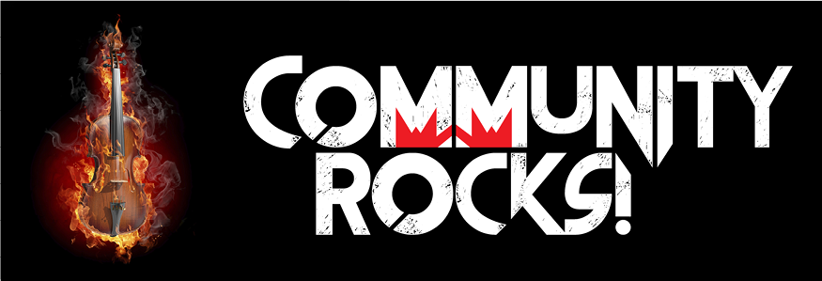 | INTERNATIONAL MUSIC CAMP  Community Rocks! Scholarship 2019 Application Form  for campers ages 10-19 who live within a 60 mile radius of Minot, ND

Applicant Information
Camper Name:
 | First | Middle Initial | Last Name Age Grade
Parent/Guardian Name:
Mailing Address:
 | City | State | ZIP
Preferred Phone: | ( ) | E-mail Address:

School Attending:

Program desired at IMC |  | Instrument/Voice Part:

Session and Dates: |  | Do you live within a 60 mile radius of the City of Minot? Circle: yes/no

Financial Information
(Note: This information is kept strictly confidential, but it is necessary to evaluate the level of this award)
Number of Adults in the Household:_______ Number of Children in the Household:_______
Household income as reported to the IRS in most recent tax year:
Below $10,000 $20,000-$25,000 $30,000-$35,000
$1
$1$10,000-$20,000 $25,000-$30,000 Above $35,000

How much can you contribute to the total fee if awarded a partial scholarship?_____________

Why do you want to attend the International Music Camp this summer?
______________________________________________________________________________________________________________________________________________________________________________________
Send application to:
International Music Camp, Attn: Scholarship Programs, 111 11th Ave SW, Suite #3; Minot, ND 58701
Phone: 701-838-8472 Fax: 701-838-1351
E-mail: info@internationalmusiccamp.com
Application deadline is 5:00pm CST, Friday, April 12, 2019
All applicants will be notified by April 23, 2019

International Music Camp
Community Rocks! Scholarship

2019 Scholarship Application
Deadline: April 12, 2019

International Music Camp Summer School of Fine Arts
Dates and Fees 2019
Session 1  June 16- June 22  □ Middle School  Band  □ Middle School  Choir  □ Middle School  Art | Session 2  June 23-June 29  □Band  □Drumline  □Digital  Photography  □Creative  Writing  □Drama | Session 3  June 30- July 6  □Band  □Garage Band  □Audio  Technology  □Musical  Theatre  □Music  Composition | Session 4  July 7-July 13  □Choir  □Choir &  Pop Choir  □Piano  □Piano/Organ  □Guitar  □Handbells  □Dance  □Basic Art  □Drawing  □University Prep A | Session 5  July 14- July 20  □Band  □Jazz Band  □Vocal Jazz  □Dance  □University Prep B | Session 6  July 21- July 27  □Orchestra  □Band  □Fiddle  □Harp  □World  Percussion  □Mallet  Percussion  □Cartooning  □Painting  □Sculpture  □University Prep C

2019 Fees
Basic Fee (full week) if registered before May 1, 2019…………………………….….$430
Basic Fee (full week) if registered after May 1, 2019………………………………….$445
Several of our programs have additional fees for music, equipment, or supplies.
Please see our website or General Brochure for the exact pricing of each program.

